TEMPLATE – instructions for authors

^{a)}Pavel Novák, ^{b)}Karel Novák, ^{c)}Alena Nováková

^{a)}Vysokáškola, ČeskéBudějovice, Czech republic, pavel.novak@novak.cz
^{b)}Novák, s.r.o., Praha, Czech Republic, karel.novak@novak.cz
^{c)}ABCD a.s., Tábor, Czech republic, alena.novakova@abcd.cz

Abstract: We accept abstracts only in English language. Abstract should not be longer than 200 words and will be published on websites of the magazine www.journalakustika.com.

Keywords: We accept keywords only in English language. Optimal 3-7 words.

INTRODUCTION

Always number the name of each chapter according to this template. Subchapters please number 1.2, 1.3., etc.

The names of each chapters may vary, but please note that name of first chapter – INTRODUCTION and last numbered chapter – CONCLUSION should be respected.

ARTICLES

2.1. Terms
We accept original articles corresponding with professional profile of our journal. For the December issue we accept articles till the middle of July (15.07.2019).

2.2. Language of articles
We accept articles in English language.

2.3. Information about author
Together with article please send also CV of all authors of the article together with their photos. We accept photos of authors only in digital form. We do not require a studio design photo. Please send minimum 300 dpi photo.

2.3. Graphic text editing
The graphic of the text is solved in relation to the overall image of the magazine, but we respect the author´s requirements on the graphic form of the text.

We accept texts in MS OFFICE, WORD *.rtf or *.doc. Tables and graphs we accept in MS OFFICE, EXCEL *.xls. Photos we accept in *.jpg or *.tiff or *.bmp or *.dngor *.psd. Please send minimum 300 dpi photo.

2.4. Font
Please use font Calibri (Basic). For the name of the article please use size 18, for chapters size 14, for subchapters size 12, and for the text size 12. Abstract, keywords, names of institutions where the author is employed, description of pictures and graphs in italics.

2.5. Number of pages
Number of pages is not limited. Together with pictures we recommend that the text should not exceed 15 pages.

IMAGES

3.1. Marking of images
Please mark the pictures as follows:

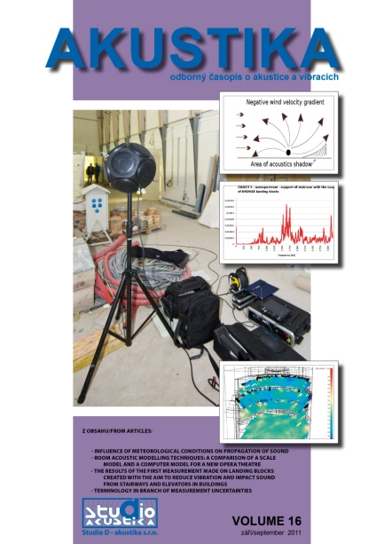
Fig. 1: Journal Akustika – VOLUME 16

3.2. Placement of images
Please send images in separate files, each with description of image. Don´t place the images into the text directly. Place the description of the picture in the place where the picture should be placed.

TABLES

4.1. Marking of tables
Please mark the tables as follows:

Tab. 1: Table – sound

Tab. 2: Table - description

4.2. Placement and format of tables
Table should be centered according to following sample:

Frequency [Hz] | Value | Value | Noise [dB] | Noise [dB] | Noise [dB]
1 | 2 | 3 | 4 | 5 | 6
4 | 1 | 2 | 3 | 3 | 5
4 | 2 | 5 | 1 | 5 | 2
2 | 5 | 8 | 2 | 5 | 8
2 | 5 | 8 | 2 | 2 | 5
2 | 2 | 2 | 2 | 2 | 5
Tab. 1: Sample table of values

FORMULAS AND VARIABLES

5.1. Formulas

Formulas are always in italics and bold. Font size is the same as text - Calibri (Basic).

Put the formulas to center and markthem as follows:

a² + b²⁺¹²³ + c_{n}³⁻¹ = x (1)
a + b = c (2)

5.2. Variables

Variables are always in italics and bold as follows: w. Font size is the same as text - Calibri (Basic).

ACCEPTANCE AND PROCESSING OF ARTICLES

Please send the articles in digital form by email conference2019@noisetp.comand barbora.majchrakova@akustikad.com.

After receiving of the article we consider whether the article corresponds with the profile and focus of the journal Akustika and with the requirements of editorial board. If the article does not correspond to these standards we will notify the author about this decision within 1 month from receiving the article.

If the author´s text meets the standards we pass the text to the Scientific Committee of Conference. Based on comments from reviewers the text may be accepted, rejected or returned to author for revision or addition. If the text is substantially altered after revision or addition, the text will be reassigned to expert reviewers for further consideration.

We reserve the right to make graphic, stylistic, terminological and grammatical contribution of articles.

CONCLUSION

Conclusion is the last numbered chapter of the article.

ACKNOWLEDGEMENT

This part is intended to thank those who helped to author with his article. This part is not numbered and is not obligatory.

REFERENCES

This part is not numbered. This part contains a list of literature. Please write references only in English language.

Please fill the references according to the sample:

[1] ČSN ISO 5725-1: Accuracy (correctness and congruence) of measurement methods and results. Part 1: General principles and definitions
[2] Petrášková, V.: Statistical methods of proficiency testing processing and evaluation, AKUSTIKA, ISSN 1801-9064, Studio D – Akustikas.r.o., ČeskéBudějovice, VOLUME 19, p. 41-47, 2013

