INVITATION TO PARTICIPATE IN ELPIT–2021 CONGRESS

DEAR COLLEAGUES,

The Organizing Committee is cordially invites you to participate in seventh International Environmental Congress "ELPIT-2021" in Samara and Togliatti cities of Russia, September 25-26, 2021.
The ELPIT conferences project started in September 2003. Since that time in interval every two years conferences are arranging in Samara region of Russia and increasing the scale. In year of 2007 ELPIT conference has received the name of the international congress. Now ELPIT Congress became the largest event in the field of ecology and of environmental and life protection in Russia where are participating over 1500 participants – famous scientists and specialists from Russia and abroad. ELPIT-2021 congress is promising to continue such good tradition.
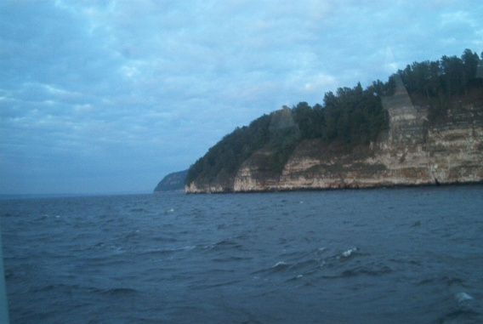
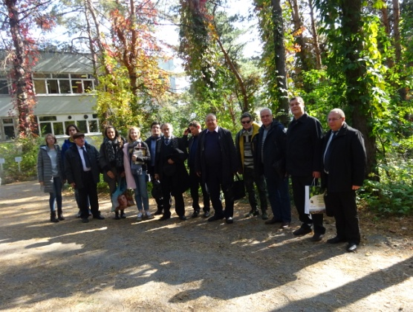
The Congress will take place in the Institute of Ecology of Volga Basin of Russian Academy of Science – branch of S Samara Federal Research Center of Russian Academy of Science, in Samara State Technical University and in Povolzhsky Orthodox Institute. During the Congress will take place a number of symposia, workshops, round tables, ecological exhibition, forum of young scientists "Young ELPIT" and other events. Taking to account COVID-19 situation, participants will have opportunity to present the papers in distance format.
Participants will have a good opportunity not only for fruitful scientific work, but also for visiting unique natural places of Middle Volga region of Russia: national Zhigulevsky reserve, national park "Samarskaya Luka"... Motor-vessel trip along the river Volga will allow to see these wonderful views nearby… Every participant will appreciate again the real charming of wonderful attraction of Middle Volga Russia and will try to understand again enigmatic "Russian spirit". Both scientific and cultural programs are promising to be very interesting.
We are sure that the congress official events, business contacts, cultural program, beautiful sights of Russia will enable to enjoy you and your partners and will make a progress in engineering ecology and in life safety!

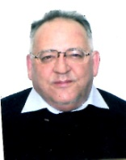
On behalf of the Organizing and Scientific Committee: Andrey Vasilyev, Congress Scientific Chairman, Co-Chairman of Organizing Committee

